For Immediate Release:

"Boland Broadcast Monitors - at the College Football Playoff National Championship game"

Lake Forest, CA- January 13, 2015 – The College Football Playoff Championship Event Monday night featured a host of pre and post game festivities, an underdog victory by Ohio State over favorite Oregon U, and numerous ESPN televised viewing options.

Broadcast monitors manufactured by Boland Communications were the main LCD technology used by Game Creek Video, the company facilitating the immense, 60 camera broadcast.

“This is a very large scale event for us,” said Pat Sullivan, president of Game Creek Video. “As far as a single client goes, this is about as big as it gets.”

Game Creek had 8 trucks on hand to support the first- of- its- kind collegiate championship, including coverage for the main game itself, outside and inside on-site studio shows, and offsite broadcast needs. On each of these trucks, Boland monitors were deployed throughout to ensure accurate and dependable video quality.

“We are fortunate to have been able to provide custom monitor solutions to Game Creek for all of these outstanding trucks” said Gary Litwin, National Sales Director at Boland. “Our goal is to make sure that come game time, our clients (and thus their clients) can count on having the most accurate, dependable, color correct screens in the business.”

Boland’s monitors were spotted in various places at AT&T field. Take a look at a few of the locations here:

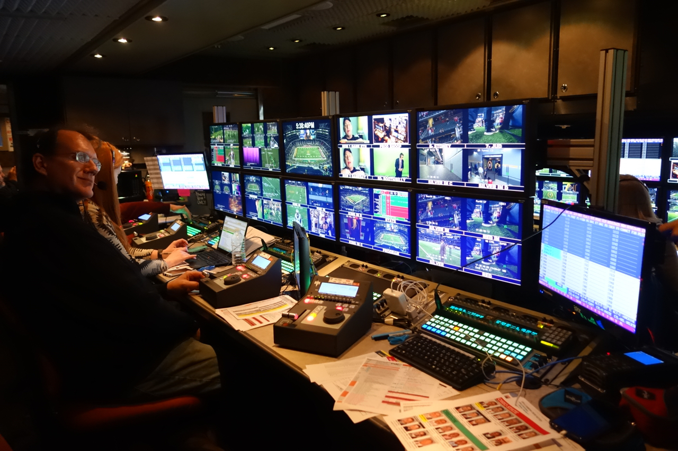

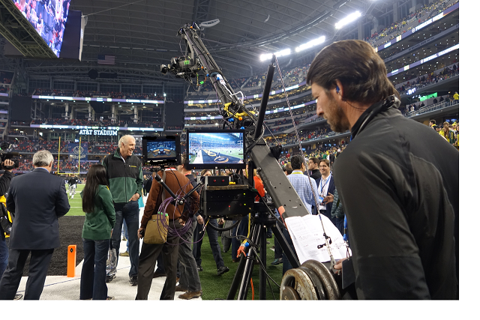

Contact:
Darick Schmitt
darick@bolandcom.com
16 Rancho Circle
Lake Forest, CA 92630 USA
Phone - (949) 465-9911

For almost Twenty Years, Boland has been creating high quality, professional broadcast monitors for film, television, aviation, and specialty needs. We are constantly pushing the LCD / monitor boundaries in new technology, outfitting our LCD monitors with the widest color gamut and ultra deep blacks. Red, green, and blue stability is guaranteed by All-Digital 12-bit Processing. Whether you are in need of a field monitor that is color critical, a low cost SDI monitor for simple confidence monitoring, or a broadcast monitor with built-in waveform, vector scope, and audio meters, Boland is proud to offer all of these options (and more).

